MINI PROJECT – II REPORT

ON

“Price Comparison using Web-scraping and Data Analysis”

A Mini Project- II report submitted in partial fulfillment of the requirement for the award of Degree of

Bachelor of Technology
(Sixth Semester)

In

COMPUTER SCIENCE & ENGINEERING
Session 2022-2023

Prescribed By
DBATU University, Lonere
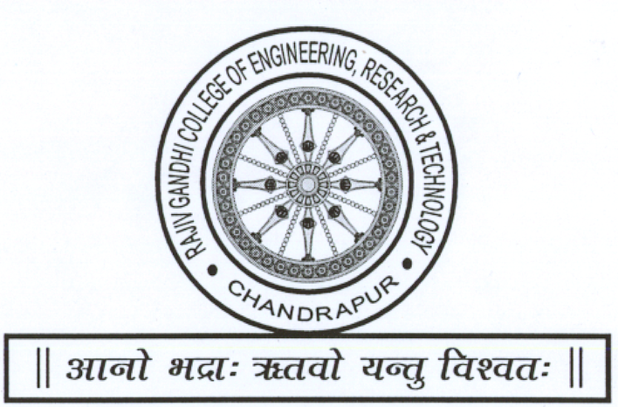

Guided By Submitted By

(Prof. Vrushali Aware) “Faizan Raza Sheikh”

“Hrishabh V. Petkar”

“Abdul Malik Sheikh”

“Harsh Lalchand Kose”

“Aditi Chanderkar”

DEPARTMENT OF COMPUTER SCIENCE & ENGINEERING
RAJIV GANDHI COLLEGE OF ENGINEERING
RESEARCH & TECHNOLOGY,
CHANDRAPUR.
Session 2022-2023

CERTIFICATE

This is to certify that, Mr. Faizan Raza Sheikh (CSEA650), Mr. Hrishabh V, Petkar (CSEA630) and Mr. Abdul Malik Sheikh(CSEA602) ans Mr. Harsh Lalchand Kose (CSEA629) and Ms. Aditi Chanderkar (CSEA601). Studying in Sixth Semester Department of COMPUTER SCIENCE & ENGINEERING,

have completed the Mini project - II

“Price Comparison using Web-scraping and Data Analysis”

satisfactorily during the Academic Session 2022-2023 from Rajiv Gandhi College of Engineering Research & Technology, Chandrapur.

Project Guide Project incharge
(Prof. Vrushali Aware) (Prof. Madhavi sadu)

Dr. Nitin Janwe
H.O.D.
CSE RCERT, Chandrapur

Rajiv Gandhi College of Engineering Research & Technology, Chandrapur
Department of Computer Science & Engineering

Institute Vision

To be on forefront to impart quality education to address societal and industrial needs and imbibe career skills through perseverance and practice.

Institute Mission

M1. To adapt innovative student centric learning methods based on
understanding and practice.

M2.To enhance professional and entrepreneurial skills.

M3.To motivate students to meet dynamic needs of the society with novelty and
creativity.

M4.To promote research and continuing education to keep the country ahead.

M5.To promote the mindset to acquire local solutions to local problems
(LS2LP).

Department Vision

To be a centre of excellence in Computer Science & Engineering by imparting knowledge, professional skills and human values.

Department Mission
M1. To create encouraging learning environment by adapting innovative student centric learning methods promoting quality education and research.
M2. To make students competent professionals and entrepreneurs by imparting career skills and ethics.
M3. To impart quality industry oriented education through industrial internships, industrial projects and partnering with industries to make students corporate ready.
Rajiv Gandhi College of Engineering Research & Technology, Chandrapur
Department of Computer Science & Engineering

Program Educational Objectives
PEO1: Impart quality industry oriented education, strong fundamentals and problem solving approach through student centric learning methods for product development and handle real time problems.
PEO2: Possess good communication skills and ethics in line with corporate environments to serve the industry & society.
PEO3: Create Competent Professionals & entrepreneurs by imparting Career skills, leadership qualities and research

Program Specific Outcomes:

PSO1: Foundation of Computer System: Ability to understand the principles and working of computer systems. Students can assess the hardware and software aspects of computer systems.
PSO2: Foundations of Software development: Ability to understand the structure and development methodologies of software systems. Possess professional skills and knowledge of software design process. Familiarity and practical competence with a range of programming languages and platforms like Cloud Computing, Web based and Mobile applications, Image and Video Processing, Artificial Intelligence & Machine Learning.
PSO3: Foundation of mathematical concepts: Ability to apply mathematical methodologies to solve computational tasks, model real world problems using appropriate data structures and suitable algorithms.

Rajiv Gandhi College of Engineering Research & Technology, Chandrapur
Department of Computer Science & Engineering

Project Title: Price Comparison using Web-scraping and Data Analysis

Project PO/ PSO Attainment

PO/PSO | Attainment  (level1=low,2= moderate,3=High) | Description
PO1
PO2
PO3
PO4
PO5
PO6
PO7
PO8
PO9
PO10
PO11
PO12
PSO1
PSO2
PSO3

Signature of Project Guide

Prof. Vrushali Aware

